Paper Recommendation with Item-level Collaborative Memory Network
Mei Yu^{1,2,3}, Yue Hu¹,2,3, Xuewei Li^{1,2,3}, Mankun Zhao^{1,2,3}, Tianyi Xu^{1,2,3,5},
Hongwei Liu⁴, Linying Xu^{1,2,3(✉)}, and Ruiguo Yu^{1,2,3}
¹ College of Intelligence and Computing, TianJin University, China
²Tianjin Key Laboratory of Advanced Networking (TANKLab), Tianjin, China
³Tianjin Key Laboratory of Cognitive Computing and Application, Tianjin, China
{yumei,huyue_ic,xuewei,zmk,tianyi.xu,linyingxu,rgyu}@tju.edu.cn
https://orcid.org/0000-0002-5169-4829
⁴Foreign Language, Literature, and Culture Studies Center, Tianjin Foreign Studies University, China
liuhongwei@tjfsu.edu.cn

Abstract. The recommendation system can recommend information to users personally and efficiently, which satisfies the user's demand for information in the information age, and has become a hot topic in the current era. In the recommendation system, users and items and the interaction of their own information has a crucial impact on the efficiency and accuracy of the recommendations. However, most of the existing recommendation systems usually design the systems as user-base only, considering the user's influence on the item in the recommendation, which to some extent blurs the interaction between items and users at the item level, unknown and potential connections between items and users are not well considered. In this paper, we propose a collaborative memory network that can focus on the potential relation between items and users, and consider the impact of items’ characteristics on user behavior. Experiments have shown that our improvement is better than the original method and other baseline models.
Keywords: Recommendation Systems, Memory Network, Collaborative Filtering.
- INTRODUCTION
In the context of the era of big data, modern recommendation systems undoubtedly become an indispensable part of people's needs in their life. As an application that filters a large amount of information, the recommendation system can collect historical behavior data of users, process the data through various processing methods or using relevant recommendation technologies, in order to obtain personalized recommendation for users and recommend information or items such as movies, music, books, news, etc. to users that users may be interested in or fond of. The data of the recommendation system includes explicit data and implicit data, the explicit data can more accurately reflect the user's real preference on items, such as user rating, etc., and the implicit data can reflect the user's preference after being analyzed and processed such as user clicks, watch time, etc. However, there are a large number of data and information that can be selected by users. The effective recommendation system can provide the most relevant content for users under the premise of large data volume, improve the efficiency and accuracy of the recommendation, and optimize the user experience. With the continuous development of digital libraries (DLs), many new knowledge is captured and stored in digital libraries. However, a large number of papers and related information lead to information overload, and there are a large number of papers matching the user's search query when making recommendations, but the information of many publications does not match the user's needs. Unlike other recommendations such as movie recommendations, the paper itself contains a large amount of information, and the user's history contains a lot of preference information. Such a large amount of data challenges the recommendation of the paper.
The recommendation system based on collaborative filtering can analyze the dependence between users and items, and use the similarity information between users to recommend content that users are interested in. The recommendation method also has a high degree of personalization and automation, at the same time, feedback can be used to speed up learning. Collaborative filtering technology is one of the most classic and mainstream technologies in recommendation systems. In real life, the user's rating data is very rare, that is, explicit data is much less than implicit data, so how to add implicit data to the model becomes a problem. SVD++ integrates the user's implicit behavior into the Singular Value Decomposition (SVD) model, enhancing the user's implicit feedback [1], which uses users' historical browsing data, users' historical review data, movies' historical browsing data and movies' historical score data, etc. as new parameters.
Another recommended system algorithm is the K-nearest neighbor classification algorithm (KNN). The core idea of KNN is to find the majority of the k most neighboring samples in a features space, if most of these samples belong to a certain category [2], then the sample also belongs to this category and has the characteristics of all samples in this category. When determining the classification, the KNN method only determines the category to which the sample to be classified belongs according to the categories of the nearest one or several samples. When making the category decision, it is only related to a very small number of adjacent samples, and is more suitable for a set of samples to be classified that intersect or overlap in a category.
Recently, Tay et al. [3] proposed a flexible adaptive metric learning algorithm for collaborative filtering and ranking. By learning the adaptive relationship vector between users and items interaction, find an optimal translation vector between each user-item interaction pair, while introducing a relational vector to simulate the potential relationship between users and items. Inspired by the memory network. Ebesu et al. [4] presented Collaborative Memory Network (CMN), they used the memory module as the nearest neighbor model of similar users, and used the attention mechanism based on specific users to learn the adaptive nonlinear weighting of the user neighborhood, while utilizing the adaptive neighborhood state and a non-linear interaction between users and items memory to generate recommendations.
Despite the success of CMN, it ignored some content. Each item has a connection with a group of users, and similar items do not necessarily have the same appeal to the same user. When considering the relevance between an item and a user, the CMN only considered the construction of neighborhood representation with similar users. However, in general, the problem of collaborative ranking has many-to-many nature, the item will also have a certain degree of impact on the user's choices and preferences, which may cause changes in the user's preferences. CMN ignored the potential relationships between items and users, especially those related to large data sets, it operates at the user level, with the user as the main body, and the information obtained comes from the user's clicks and the impact between similar users.
To solve this problem, we propose a network called Item-level Collaborative Memory Network (ICMN) for ranking and paper recommendation, which can fully consider the distribution of potential relationships between items and users and strengthen the relationship between the specific item and neighborhoods, it can take into account the impact of users and items on each other and their neighborhoods. Specifically, in order to be able to take into account the potential relationship between items and users, we adopt a higher-order method to obtain the weighted sum of the relationship between the specific item and the user and the neighborhoods they formed. Undoubtedly, our work has been inspired by the latest developments in NLP and recommendation systems [4]. The experimental results show that our method is better than CMN and other baseline models, it can capture the hidden semantics between implicit interactions.
Our contributions are summarized as follows:
• We propose ICMN, a new type of item-based network that is used to generate rankings for paper recommendations. For the first time, we have fully considered the distribution of potential relationships between items and users on CMN, and strengthened the relationship between specific items and neighborhoods.
• We also consider the impact of items and users on each other and their neighborhood. At the same time, neurological attention provides greater insight and interpretability for this model.
• We evaluate our proposed ICMN on a public dataset. Experiments have shown that our proposed ICMN is not only superior to CMN, but also superior to many other powerful baselines with improved performance.
- RELATED WORK
  - Collaborative Filtering
Usually, in implicit collaborative filtering, if there is an interaction between the user and the item, it is recorded as 1, otherwise 0. However, this does not indicate that the feedback between the user and the item that has generated the interaction is positive or negative. In a traditional data-based approach, all unobserved interactions are treated as negative samples and have the same weight, but unobserved interactions and data may be positive or missing data, and also have different weights. To this end, some recent efforts have focused on weighting schemes and have considered whether unobserved samples are indeed negative. For example, certain non-uniform weighting schemes on negative samples, such as user-oriented and item popularity orientation, have been proposed and proven to be more effective than uniform weighting schemes. However, one major limitation of the non-uniform weighting method is that the weighting scheme is defined based on the hypothesis proposed by the authors, which may not be correct in the actual data.

  - Attention Mechanism
The attention mechanism has a great improvement effect on the sequence learning task. The attention model can perform data weighted transformation on the data sequence. Xu et al. [6] proposed two attention modes, one is hard attention and the other is soft attention. Hard attention only pays attention to a certain position of the model sequence at each moment, when soft attention takes care of all the positions at a time, and the weight of each position is different. Luong et al. [6] proposed two improved attentions, namely global attention and local attention. Among them, local attention can be regarded as a mixture of hard attention and soft attention. Unlike hard attention, local attention can be differentiated almost everywhere and easy to train, it only focuses on a small part of the source position at a time, and global attention needs to scan all source hidden states each time.

  - Deep Learning
Deep learning stems from the research of artificial neural networks, is one of the latest trends in artificial intelligence and machine learning research, and is one of the most popular scientific research trends today. It combines low-level features to form more abstract high-level way to represent attributes categories or features to discover the distributed feature representation of the data [8]. The deep learning approach has brought historic progress to machine learning. In the study of machine learning, the motivation of deep learning lies in the establishment and simulation of a neural network for the analysis and learning of the human brain. It can mimic the mechanism of the human brain to interpret data such as images, sounds and texts, etc.
In the recommendation system, the general idea of common algorithms is to convert high-dimensional discrete features into fixed-length continuous features through the embedding layer, then pass through multiple fully connected layers, and finally convert to a 0-1 value through a sigmoid function to representing the probability of clicks. This method can fit high-order nonlinear relationships through neural networks while reducing the workload of artificial features.

  - Collaborative Memory Network (CMN)
CMN is a recent deep architecture that demonstrates excellent and competitive performance in several baseline tests. In this network, memory components and neural attention mechanisms are merged into neighborhood components to learn about the user's specific neighborhood. The ranking score is generated by the neighborhood and user memory [4].
CMN focuses its attention on users' information, which leads to the neglect of information about items. In the process of the user's interaction with the item, in addition to the explicit relationship, there is an implicit relationship. At the same time, in addition to the users' influence on items, the items also have a non-negligible connection with users. Similar items do not necessarily have the same appeal to the same user and items that have not interacted with the user will also affect the user's choice to some extent.
In real life, the channels through which users can accept items information are diverse, which means that different information will make the characteristics of the item have different effects on users. At the same time, it also shows that CMN cannot flexibly recommend in the case of huge data volume and dense dataset.
- Item-level Collaborative Memory Network
In this section, we will introduce our network model Item-level Collaborative Memory Network (ICMN) that can focus on the item's attractiveness and potential relationships to users. The overall architecture and construction process of our network model has shown in Fig. 1.

  - Source of Inspiration
Our inspiration comes from the CMN model which combines the memory component and the neural attention mechanism to form a neighborhood component that learns the user's specific neighborhood [4]. The model with the stacking of the two memories enables them to obtain a deeper relationship between the user and the item. In a single-layer memory, given a user u, a preference vector $q_{ui}$ for a particular user v is formed, and then a similarity $q_{uiv}$ of a particular user to a user in the user neighborhood is derived, which is represented by $q_{uiv}=m_{u}^{T}m_{v}+e_{i}^{T}m_{v}$.When constructing the final neighborhood representation, the CMN constructs a neighborhood representation $p_{uiv}$ for a particular user for subsequent operations. We focus on items information and their features, embedding users and items, and using different methods to get the final neighborhood $s_{iu}$ for a particular item. On this basis, we get the final ranking score.

  - User and Item Embedding
The input user and item information are embedded in the memory component of the user and the item respectively. The user's memory component is M, and the item's memory component is E, where $M∈R^{P×d}$, $E∈R^{Q×d}$ ，P and Q are the number of users and items, d is the dimension of the memory. The users' preferences are stored in the user memory component slice $m_{u}$, and the features of the item i are stored in $e_{i}$ of the item memory slice to get the similarities $a_{iut}$ for a particular item and a particular user in its given neighborhood:
$a_{iut}=m_{u}^{T}e_{t}+e_{i}^{T}e_{t} ∀t∈N\left(u\right)$ (1)
Where t is a specific item in the item neighborhood with implicit feedback.

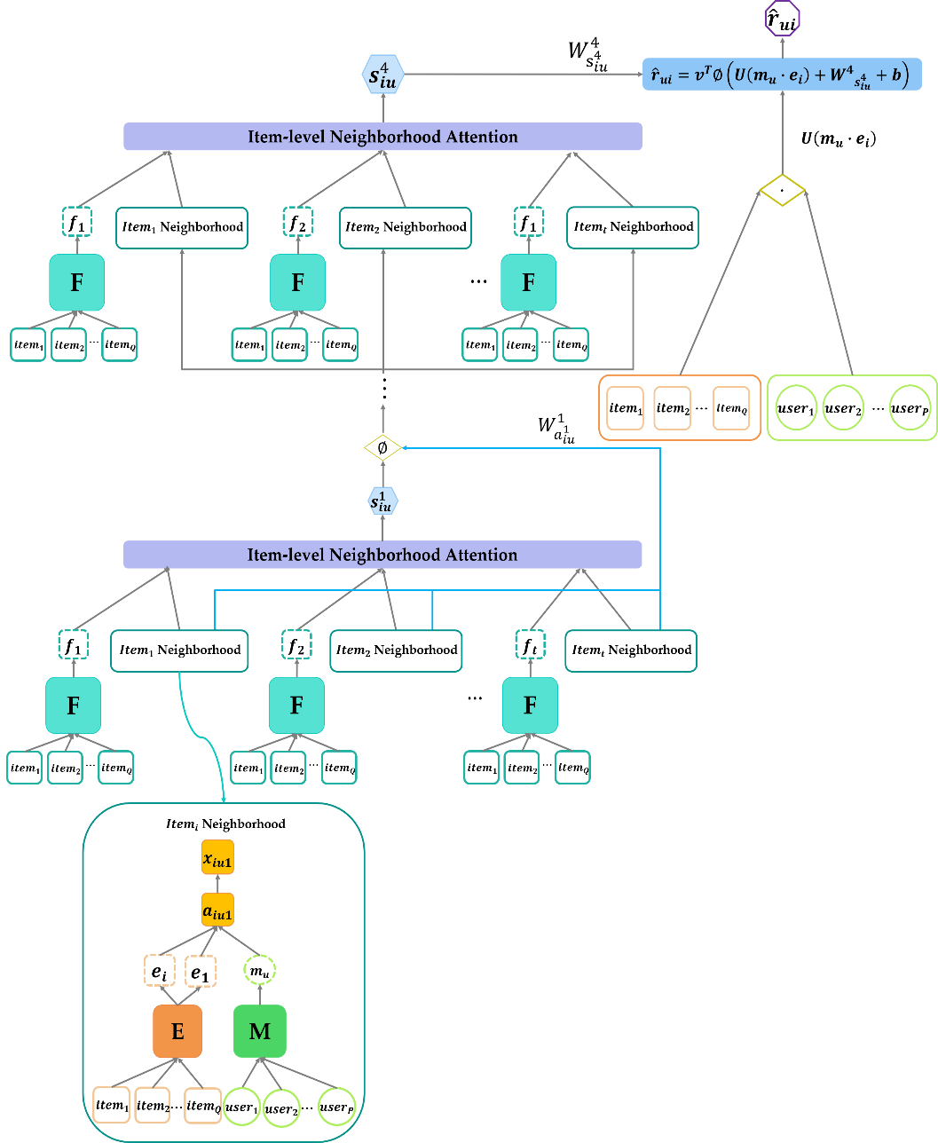
Fig. 1. Our model structure. This model can focus on item information and build with four layers of memory components.

  - Item Neighborhood Attention
In order to focus on the influential set of items and users in the neighborhood, the attention mechanism can learn the adaptive weighting function, which is different from the traditional neighborhood method used in Pearson correlation or cosine similarity, the function does not need to set the number of users or items. At the same time, we do not need to pre-define or set the weighting function based on past experience in the learning process of the whole attention mechanism. In this way, we can better learn the unique contribution of items:
$x_{iut}=\frac{exp\left(a_{iut}\right)}{\sum_{g∈N\left(u\right)}{exp\left(a_{iut}\right)}} ∀t∈N\left(u\right)$ (2)
Among them, the generated neighborhood distribution can be dynamically assigned to specific item.
Then, by using the weights formed by the attention mechanism, the weights are manipulated with the neighborhood to form the neighborhood representation:
$s_{iu}=\sum_{t∈N\left(u\right)}{x_{iut}{×f}_{t}}$ (3)
Where $f_{t}$ is the vector of another embedded matrix of items, $×$ is the operation at the matrix level. Focusing on the characteristics of items, the weights formed by the attention mechanism are selectively weighted to items and their neighborhoods in different ways to obtain the final weighted neighborhood.
This not only consider the impact of items on users, but also strengthens the relationship between the specific item and the neighborhood, taking into account the distribution of the potential relationship between items and user.

  - Memory Stack
Throughout the model building, we operate with a stack of four memories that capture deeper and broader information between items and users, improving the efficiency and performance of the entire model. Through the stacking of memories, it can dynamically assign weights to items, and capture the appeal of the item to users more comprehensively and in detail. Using the $s_{iu}^{y}$ generated by the upper memory, a non-linear mapping $z_{iu}^{y}$ between the memories can be formed for next memory, and then $a_{iut}^{y+1}$ can be obtained by updating with the item neighborhood, and finally, after the four layers of memory components, the final neighborhood representation is obtained:
$z_{iu}^{y}=σ\left(W_{a_{iu}^{y}}^{y}+s_{iu}^{y}+b\right)$ (4)
$a_{iut}^{y+1}$$= {\left(z_{iu}^{y}\right)}^{T}e_{t} ∀t∈N\left(u\right)$ (5)
Where $σ\left(x\right)=1/\left(1+exp\left(-x\right)\right)$ is the nonlinear activation sigmoid function, y is the number of memory layers, and W is a weight matrix that maps the features of items to the potential space, combined with the information of the previous layer.

  - Output
By capturing the local structure of items and users' neighborhood and the global interaction information between items and users, items and users have established a deeper and wider relationship, and then through a non-linear approach, the potential relationship between items and users can be more fully reflected to generate a ranking score that focuses on the items' influence:
${\hat{r}}_{iu}=v^{T}∅\left(U\left(m_{u}∙e_{i}\right)+W_{s_{iu}^{4}}^{4}+b\right)$ (6)
Where $∙$ is the operation of the element level. After obtaining the product of items and users, we learn the neighborhood representation and parameters by linear projection. We use the nonlinear activation function $∅\left(x\right)=max\left(0,x\right)$, which can improve the expressive ability of the model [9], the overall structure of the model shown in Fig. 1.

  - Parameter Estimation
We use the Bayesian Personalized Ranking (BPR) optimization standard [12] as our loss function:
$L=\sum_{\left(u,i^{+},i^{-}\right)}{\log{σ\left({\hat{r}}_{i^{+}u}-{\hat{r}}_{i^{-}u}\right)}}$ (7)
Where $σ\left(x\right)=1/\left(1+exp\left(-x\right)\right)$ is the logical sigmoid function.
- PERFORMANCE EVALUATION
In this section, we will introduce the dataset and baseline settings used in the experiment.

  - Dataset
The dataset we use is the citeulike-a dataset [9], an online service collected from CiteULike, which allows users to create their own collection of articles. Each article has a summary, title and label, and the user provides a digital catalog to save and share academic papers. And the dataset has 204,987 ratings, 5,551 users and 16,980 items.

  - Baselines
In this section, we will introduce the excellent baselines used in our experiments.
SVD ++: SVD ++ [1] is a hybrid model that combines neighborhood-based similarity and latent factor model.
GMF: The Generalized Matrix Factorization (GMF) [10] model is a nonlinearly extended potential factor model.
KNN: KNN [2] is a neighborhood-based method for calculating cosine item-item similarity.
BPR: Bayesian Personalized Sorting (BPR) [12] is a matrix factorization model of implicit feedback.
NeuMF: Neural Matrix Factorization (NeuMF) [10] is a matrix factorization model for item ordering through a multilayer perceptron model.
CDAE: Collaborative Denoising Automatic Encoder (CDAE) [13] is an item-based deep learning model.
FISM: Factored Item Similarity Model (FISM) [14] is a neighborhood-based model that can decompose the similarity matrix of item-item pairs and optimize the loss function.
CMN: Collaborative Memory Networking [4] is a model that fuses memory components and attention mechanisms and is the source of our ideas.
In addition, after several comparison experiments, we found that the setting of the number of negative samples has an impact on the recommended performance. The recommended performance improves with the increase of negative sample size, but will tend to stabilize at a certain negative sample size, as shown in Fig. 2. Based on the results of the comparative experiment, we set the number of negative samples as 4 and initialize in pre-training. In pre-training, l2's weight decay is set to 0.001. During training, l2's weight decay is set to 0.1, the embedded size d of the memory is set to 50.

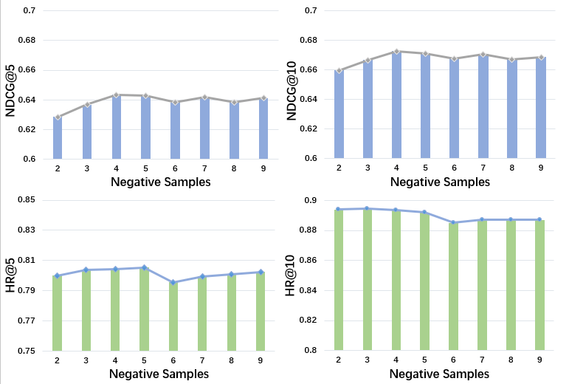
Fig. 2. Comparative experiment of negative sample number.

We use two common ranking evaluation metrics Hit Ratio (HR) and Normalized Discounted Cumulative Gain (NDCG) [12] as the basis for the evaluation of experimental results:
$HR@K=\frac{NumberofHits@K}{\left|GT\right|}$ (8)
$NDCG@K=\frac{DCG@K}{Ideal DCG@K}$ (9)
Where HR can measure the presence of the positive item within the top N, $\left|GT\right|$ is all test sets and the numerator is the sum of the number of test sets belonging to each user's top-K recommendation list. NDCG can measure the items position in the ranked list and penalize the score for ranking the item lower in the list, DCG is the average Discounted Cumulative Gain,$Ideal DCG@K$ is the largest DCG value under ideal conditions.

Table 1. Citeulike-a dataset experiment results.
 | HR@5 | HR@10 | NDCG@5 | NDCG@10
SVD++ | 0.6952 | 0.8199 | 0.5244 | 0.5649
GMF | 0.7271 | 0.8326 | 0.5689 | 0.6034
KNN | 0.6990 | 0.7348 | 0.5789 | 0.5909
BPR | 0.6547 | 0.8083 | 0.4858 | 0.5357
NeuMF | 0.7629 | 0.8647 | 0.5985 | 0.6316
CDAE | 0.6799 | 0.8103 | 0.5106 | 0.5532
FISM | 0.6727 | 0.8072 | 0.5106 | 0.5545
CMN | 0.7959 | 0.8921 | 0.6185 | 0.6500
ICMN | 0.8044 | 0.8934 | 0.6434 | 0.6726

  - Baseline Comparison
The data in Table 1 shows the experimental results of our model and each baseline model. At the same time, we also show the results of our model and other baseline models on four indicators in a more intuitive way in Fig. 3. It can be seen that our results have good results and performance on these four indicators.
ICMN can consider the impact of the relevant information and characteristics of items on user preferences, and prove the importance of items' own information in the recommendation process. The stacking of four layers of memories further optimizes performance, and the dynamic processing of weights by the attention component enables the model to focus on deeper information. The results prove that our model is superior to all baseline models.

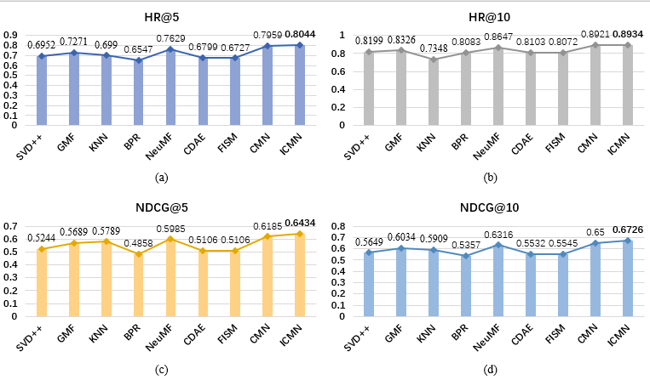
Fig. 3. Visualization of experimental results. (a)(b)(c)(d) are the results of our and other baseline models in the Citeulike-a dataset with HR@5, HR@10, NDCG@5 and NDCG@10 as the evaluation indicators.
- CONCLUSION
In this paper, we propose an item-level collaborative memory network (ICMN) that can focus on the impact of the item level, which not only takes into account the attractiveness of items to users, but also fully considers the distribution of the potential relationship between items and users to strengthen the relationship between the specific item and neighborhoods and enables our network to perform well on larger data sets. Attention mechanisms can also handle items' features more rationally and dynamically to obtain more comprehensive user preference information. In future work, we want to add time information or other information that can more fully reflects the relationships between users and items to our network.

Acknowledgment. This work is supported in part by the National Natural Science Foundation of China (No.61877043) and the National Natural Science Foundation of China (No.61877044)

References
- Yehuda Koren.: Factorization meets the neighborhood: a multifaceted collaborative filtering model. In: 14th ACM SIGKDD International Conference on Knowledge Discovery and Data mining, pp.426-434. ACM, Las Vegas, Nevada, USA (2008).
- Francesco Ricci, Lior Rokach, and Bracha Shapira.: Introduction to recommender systems handbook. Recommender Systems Handbook. Springer, Boston, MA (2011).
- Yi Tay, Luu Anh Tuan, Siu Cheung Hui.: Latent Relational Metric Learning via Memory-based Attention for Collaborative Ranking. In: 27th International Conference on World Wide Web, pp.729-739. ACM, Lyon, France (2018).
- Travis Ebesu, Bin Shen, Yi Fang.: Collaborative Memory Network for Recommendation Systems. In: 41st ACM SIGIR International Conference on Research & Development in Information Retrieval, pp.515-524. ACM, Ann Arbor, MI, USA (2018).
- Sudha Subramani, Hua Wang, Huy Quan Vu, Gang Li.: Domestic Violence Crisis Identification From Facebook Posts Based on Deep Learning. IEEE Access(6), 54075-54085 (2018).
- Kelvin Xu, Jimmy Ba, Ryan Kiros, Kyunghyun Cho, Aaron Courville, Ruslan Salakhutdinov, Richard Zemel, Yoshua Bengio.: Show, Attend and Tell: Neural Image Caption Generation with Visual Attention. In: 32nd International Conference on Machine Learning, pp.2048-2057. ACM, Lille, France (2015).
- Minh-Thang Luong, Hieu Pham, Christopher D.: Manning Effective Approaches to Attention-based Neural Machine Translation. In: 12th International Conference on Empirical Methods in Natural Language Processing, pp.1412–1421. ACL, Lisbon, Portugal (2015).
- Ian Goodfellow, Yoshua Bengio, and Aaron Courville.: Deep learning. MIT Press (2016).
- Giuseppe Amato, Fabio Carrara, Fabrizio Falchi, Claudio Gennaro.: Efficient Indexing of Regional Maximum Activations of Convolutions using Full-Text Search Engines. In: 7th International Conference on Multimedia Retrieval, pp.420-423. ACM, Bucharest, Romania (2017).
- Xiangnan He, Lizi Liao, Hanwang Zhang, Liqiang Nie, Xia Hu, and Tat-Seng Chua.: Neural Collaborative Filtering. In: 26th International Conference on World Wide Web, pp.173-182. ACM, Perth, Australia (2017).
- Chong Wang, and David M Blei.: Collaborative topic modeling for recommending scientific articles. In: 17th ACM SIGKDD International Conference on Knowledge Discovery and Data mining, pp.448-456. ACM, San Diego, California, USA (2011).
- Steffen Rendle, Christoph Freudenthaler, Zeno Gantner, Lars Schmidt-Thieme.: BPR: Bayesian personalized ranking from implicit feedback. In: 25th International Conference on Uncertainty in Artificial Intelligence, pp.452-461. AUAI, Montreal, Quebec, Canada (2009).
- Yao Wu, Christopher DuBois, Alice X. Zheng, and Martin Ester.: Collaborative Denoising Auto-Encoders for Top-N Recommender Systems. In: 9th ACM International Conference on Web Search and Data Mining, pp.153-162. ACM, San Francisco, California, USA (2016).
- Santosh Kabbur, Xia Ning, and George Karypis.: FISM: factored item similarity models for top-n recommender systems. In: 19th ACM SIGKDD International Conference on Knowledge discovery and data mining, pp.659-667. ACM, Chicago, Illinois, USA (2013).
- Francesco Ricci, Lior Rokach, and Bracha Shapira.: Introduction to recommender systems handbook. Springer, Boston, MA (2011).

